Characteristics of Strawberry Varieties Produced in Japan
(Excerpted from the fruit information website Kudamononavi)
https://foodslink.jp/syokuzaihyakka/fruit

Amaou Strawberries (Fukuoka Prefecture)
Amaou strawberries are known for their large size, and berries exceeding 20 g are frequently seen. They also have a pretty, rounded shape. The flesh is firm and juicy and has a good flavor with a balanced sweetness and acidity.
The name was chosen through a public naming contest in the prefecture. Amaou consists of the first syllables of the Japanese words for red (akai), round (marui), large (okii), and delicious (umai) and is also a play on words containing the meaning of “aspiring to be the king of sweet strawberries.” They are also called Hakata Amaou.
Amaou strawberries have a rich flavor so we recommend eating them plain without condiments. Of course, it would also be nice to add condensed milk and enjoy the milky sweetness.
Their moderate acidity also makes them a good choice for jam, tarts, cakes, smoothies, and other desserts. Their large size makes them attractive decorations on a cake or tart. The deep red pulp produces a beautiful crimson jam.
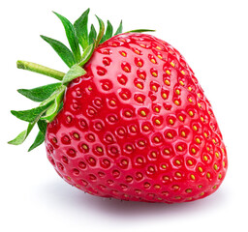

Koiminori Strawberries (Nagasaki Prefecture)
Koiminori strawberries are moderately firm, have a pleasant fragrance, and well-balanced sweetness and acidity. They have a slightly rounded, short cone shape and are large and heavy at roughly 18 g. The skin is glossy with a vivid rosy to red color, and the flesh is basically white. The berries are highly fragrant with a balanced sweetness and acidity.
The name Koiminori is derived from the wish for love to be requited through the strawberries.
We recommend quickly rinsing the fragrant, flavorful Koiminori berries in running water and eating them plain. Cutting them in half and serving them on a plate is also a good option due to their large size.
They should be rinsed first before cutting because the juice and nutrients will be washed away if rinsed after cutting.
They are naturally well suited for cakes and parfaits. Since the flesh is white, however, it is advisable to make sure the red skin is visible when decorating a parfait with cut strawberries.
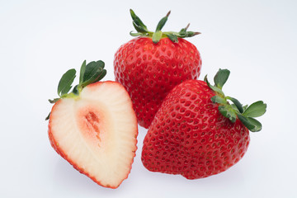

Yumenoka Strawberries (Nagasaki Prefecture)
While Yumenoka strawberries have a high sugar content, they also have acidity that results in a refreshing taste.
The berries are cone shaped and on the large side, weighing about 20 g. The flesh is moderately firm and very juicy. The well-balanced sweetness and acidity give the berries a flavorful, sweet tartness. The name Yumenoka is said to contain the meaning of “a delicious strawberry that fulfills everyone’s dream”.
They are well balanced in sweetness and acidity, so rinse them and eat them plain. If you feel they are too tart, you can top them with condensed milk or chocolate, or blend them into strawberry milk.
Because Yumenoka berries are somewhat acidic, they go well with fresh cream and are optimal for parfaits and cakes. They also taste delicious as jam or puree.
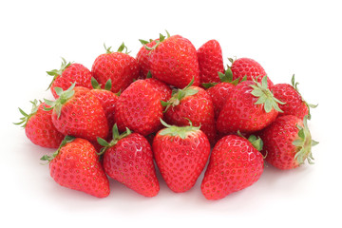

Koinoka (Nagasaki Prefecture)
Koinoka is also written with the Japanese kanji characters for love (koi) and fragrance (kaori), but the official name is written in the Japanese hiragana syllabary. The name is said to derive from the fact that they are sweet when you eat them, and this evokes the sweetness of love.
The berries are cone shaped to elongated cone shaped and have a glossy, bright red skin. The flesh is white with a light orange to pale red center. They are medium sized with a good balance of sweetness and acidity. The berries are firm and keep well for extended periods.
They are flavorful and good to eat plain after a quick rinse.
The sweet flavor also contains a moderate amount of acidity, so they pair well with fresh cream and are a great choice for making cakes for the Christmas season. These strawberries can also be used in parfaits, tarts, and smoothies. Berries that have gone soft can be enjoyed in delicious jam and strawberry sauces.
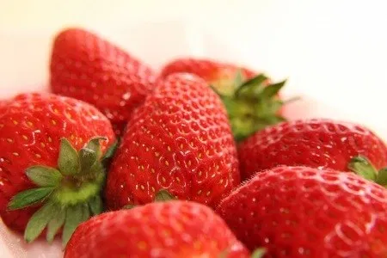

Kaorino Strawberries (Nagasaki and Kumamoto Prefectures)
Kaorino strawberries are large and cone shaped, with orangish-red skin. The flesh is pure white to the center, and this variety provides a pretty contrast between the red edge and white flesh when cut.
The flesh is firm with a strong sweetness and mild acidity. A major characteristic of Kaorino strawberries is their superb fragrance. These berries contain an ample amount of linalool, which provides the fresh sweet scent. The synergistic effect of this scent combined with the sweetness of the berries brings out their abundant flavor.
This variety is fragrant and sweet, so it is best enjoyed fresh. You can use these berries just like a topping on parfaits and desserts without cutting them. They are also gorgeous when cut and arranged to display the white flesh and red skin in an alternating fashion.
Berries that have grown soft can be used in jams. Since Kaorino strawberries are not very acidic, however, adding a little more lemon than usual will enhance their delicious flavor.
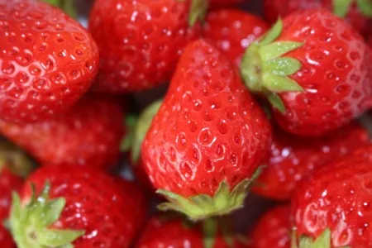

Youbeni Strawberries (Kumamoto Prefecture)
Youbeni strawberries are a variety that is unique to Kumamoto Prefecture. They debuted in 2015.
The berries are on the large side and display well in an array, with a pleasing cone shape. The skin is a lustrous bright red and the red color extends into the flesh. The firm, juicy berries are well balanced in sweetness and acidity and have a rich flavor.
The name Youbeni contains the character for kuma in Kumamoto, which is also pronounced as “yū”, and the character for red, pronounced as “bӗnī.” They are named for their bright red skin.
Youbeni strawberries are flavorful, and we recommend eating them plain. Just quickly rinse them and eat them. The sugar content of Youbeni berries contains a high percentage of sucrose, so you can really taste the sweetness.
They are beautiful with a pleasing shape and red color that extends into the flesh, so they are good for making parfaits and cakes.
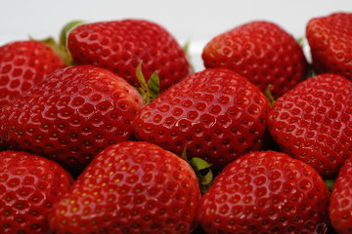

Ichigosan Strawberries (Saga Prefecture)
The strawberries bearing the unique name of Ichigosan were developed by Saga Prefecture over seven years, and are said to have been selected from some 15,000 strains. This is the first new variety introduced since the Saga Honoka debuted 20 years ago.
The brand name of Ichigosan was chosen because it is a name that is easy for everyone to pronounce and remember, from children to adults. The advertising slogan is “charming to look at and sweet to bite.”
The berries are large and cone shaped and have a deep red skin. They are known for their red color extending into the flesh. The berries have a mild, sweet flavor and the flesh is juicy and fragrant, making them nice to both eat and look at.
The best way to enjoy them is to rinse them with water and eat them to savor the juicy fresh sweetness and mild acidity. Overly ripened berries are good in jam and smoothies.
Ichigosan strawberries have a deep-colored skin and the flesh is also red when cut so we recommend them for use in cakes, tarts, parfaits, and other desserts. Arrange them to show the deep red cross-section of the sliced berries when using them as a topping.
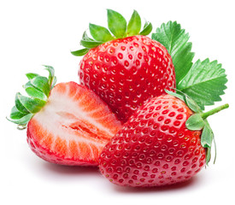

Saga Honoka Strawberries (Saga Prefecture)
Saga Honoka strawberries are from Saga Prefecture as the name Saga suggests. They are mainly cultivated in Saga Prefecture and other prefectures in the Kyushu region.
The skin is a glossy crimson color, and the flesh is beautifully white. The berries are very juicy with a strong sweetness and mild acidity. They are large and cone shaped, have firm flesh, and keep well for an extended period. These berries are sometimes displayed as Honoka or Honoka Ichigo at stores.
Saga Honoka berries are not very acidic, so they are quite delicious even without condensed milk or other sweet toppings. Rinse them and eat them plain.
The strong fragrance makes them a good choice for use in cakes, etc. to create a delicious dessert. The flesh is white, so we recommend using them whole as a topping to show the red color of the berries.
Rika-chan was used as the character image for Saga Honoka strawberries in the past. It is said that the intention was to appeal, not just to children, but to homemakers and women who used to play with Rika-chan dolls. The bright red berries and the cute Rika-chan character were a perfect fit.
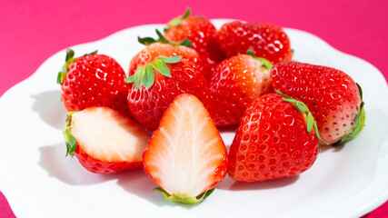

Sanukihime Strawberries (Kagawa Prefecture)
Sanukihime strawberries originated in the former province of Sanuki no Kuni in Kagawa Prefecture and are pretty berries with delicate taste. The name contains the meaning of wanting many people to cherish them.
Sanukihime berries are known for their rounded cone shape. They are on the large side, and the moderately firm flesh is very juicy. The berries have a high sugar content, are refreshingly acidic, and highly fragrant. They are produced in Kagawa Prefecture and are mainly shipped to the Kinki area.
The name Sanukihime conveys the image of strawberries grown in Kagawa Prefecture, which is equated with Sanuki, and is said to contain the hope that they will be cherished by many people. The official name of the variety contains the Japanese kanji character for hime (princess), but they are shipped in packs labeled with Sanukihime in the hiragana syllabary.
Enjoy the juicy sweetness of fully ripened fresh Sanukihime berries. The pretty rounded shape makes them a fun topping for cakes, parfaits, and other desserts.
Their moderate acidity also makes them a nice choice for strawberry milk, smoothies, and jam.
